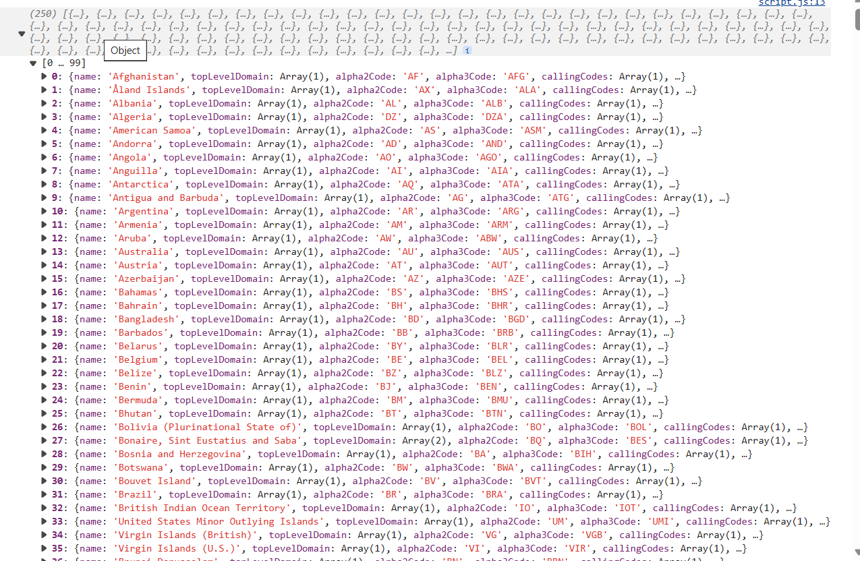

b.Get all the countries with a population of less than 2 lakhs using Filter function

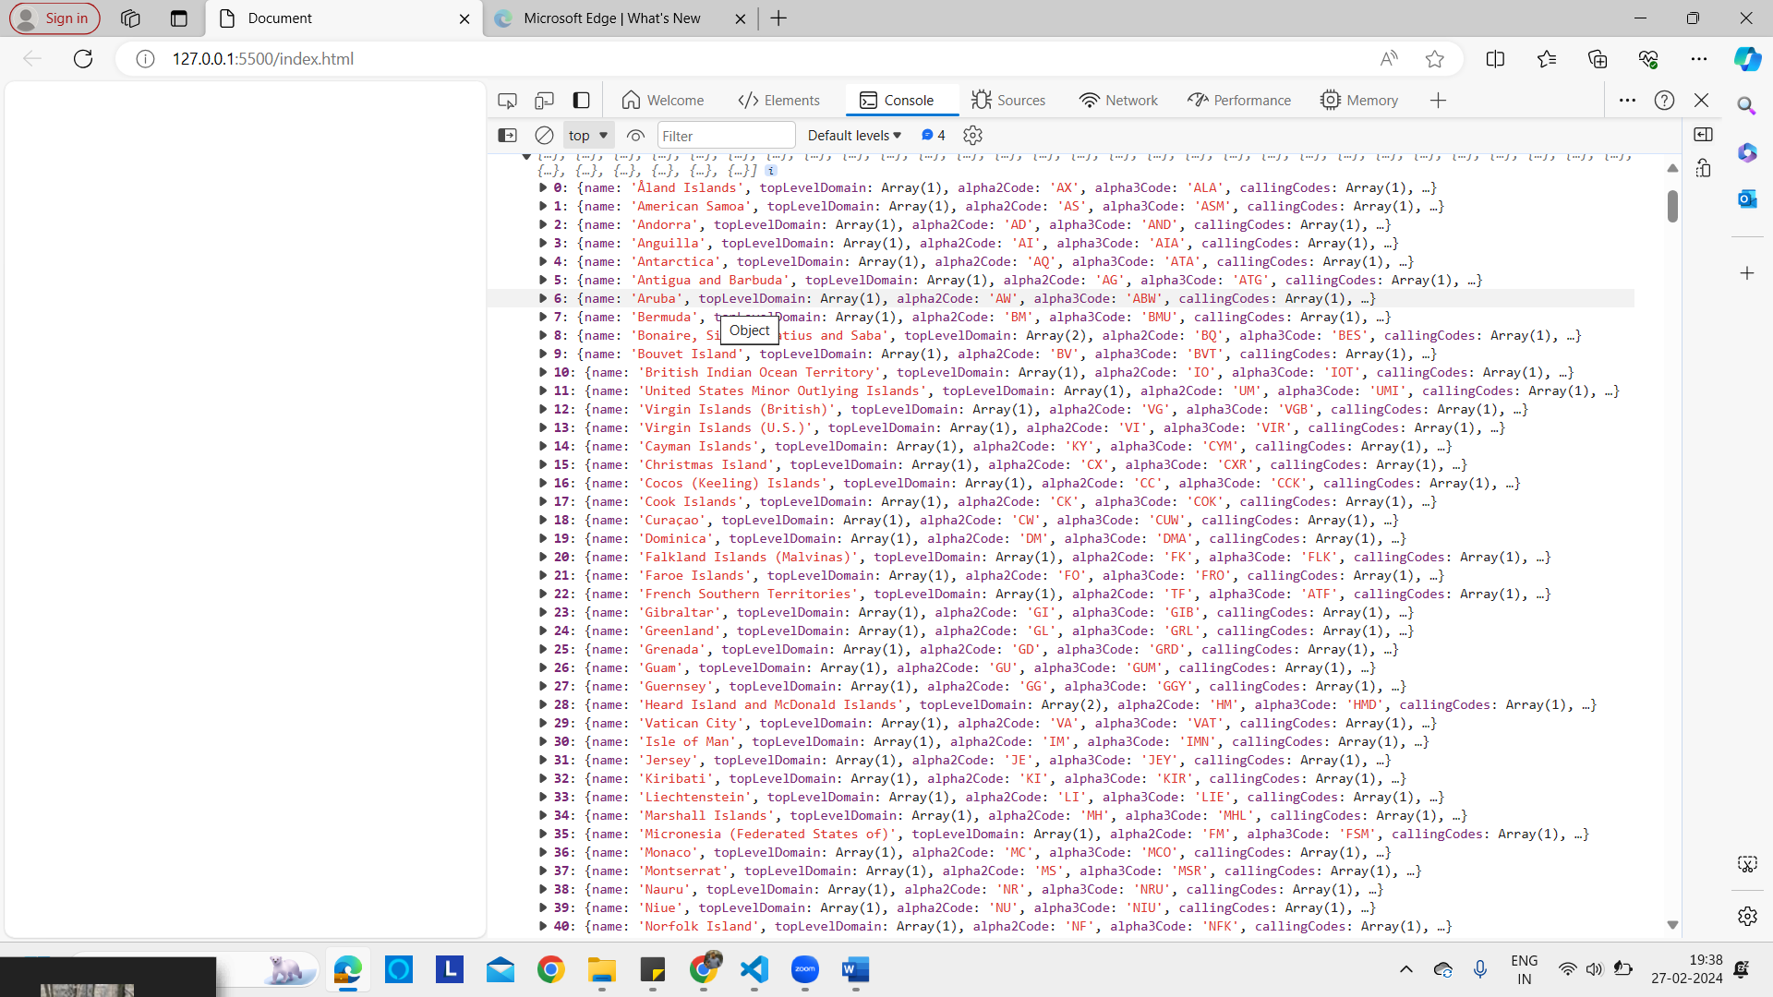

c.Print the following details name, capital, flag using forEach function

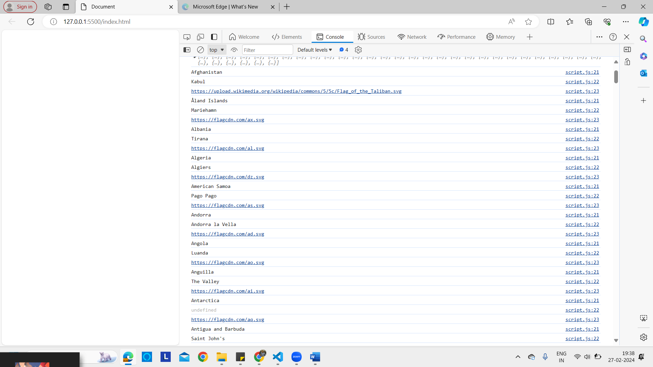

d.Print the total population of countries using reduce function



e.Print the country which uses US Dollars as currency

